Best Practices to Data Modelling within Global Data &
Artificial Intelligence

Version: 2
Last updated: 22.11.2024

Contents
1. Introduction 3
2. Types of Data Models 4
2.1 Conceptual Data Model 4
2.2 Logical Data Model 4
2.3 Physical Data Model 5
3. Roles & Responsibilities 6
3.1 Data Steward 7
3.2 Data Architect/Modeler 7
3.3 Delivery/DevOps Team 7
3.4 Data Governance Lead 8
3.5 Data Owner 8
3.6 Data Maintainer 9
4. Best Practices for Creating a Data Model 10
4.1 Basic Principles 10
4.2 Best Practices Overview 10
4.2.1 Purpose 12
4.2.2 Ownership 12
4.2.3 Business approval 12
4.2.4 Entities 12
4.2.5 Definitions 12
4.2.6 Naming 13
4.2.7 Normalization 13
4.2.8 Atomicity 14
4.2.9 Integrity 14
4.2.10 Data Redundancy 14
4.2.11 Performance 15
4.2.12 Scalability 15
4.2.13 Validation 16
4.2.14 Documentation 16
4.2.15 UML 17
4.2.16 Coherence 17
4.2.17 Reuse 17
4.2.18 Industry standards 18
4.2.19 Syntactical checks 18
4.2.20 Sharing 18
5. References 19

1. Introduction
This document provides a high-level introduction to data modelling, and outlines the current best practices established for the data modelling discipline carried out within Global Data & AI (GDAI).

Data modelling creates a visual description of a business by analysing, understanding, and clarifying data requirements and how they underpin the business processes. The data and its relationships are uncovered, providing a better understanding of the business processes and areas where they might be improved from a data perspective. With the continuous increase in the amount of data used across Novo Nordisk a good and comprehensive overview of the data landscape is becoming crucial, in the effort to increase standardisation and enable easy and consistent use of data going forward.

Establishing best practices within data modelling give model owners and model developers a shared language that promotes collaboration and enables more re-use and compatibility of data. The goal of creating best practices for data modelling is to create the basis for effective communication.
- Effective communication between business and IT throughout the development process from idea to implementation.
- Effective communication between modellers through recognisable modelling expressions and standardisation of model elements and metadata.
- Effective communication between IT systems by providing a basis for direct reuse of concepts and model data defined by the business in actual system data exchanged between IT systems.

In this document you will find answers to the following questions:
- What is a conceptual, logical and physical data model – and the basics
- Who is responsible for creating and updating a data model in GDAI
- What are the basic modelling principles for GDAI data models

Before proceeding, make sure you’ve covered these basics:
- Do you have Erwin installed?
- Are you updating an existing model or creating a new one?
- Do you know the model approval process?
- Are you familiar with Erwin Mart?

2. Types of Data Models
There are three main types of data models, each serving a different purpose in the database design process and providing varying levels of detail.

2.1 Conceptual Data Model
- Purpose: The conceptual data model is designed to provide a high-level overview of the data landscape. It focuses on the business and its requirements, rather than the technical details.
- Components: It includes major entities and the relationships between them, but it does not specify attributes or data types.
- Audience: This model is typically used by business stakeholders and data architects to ensure that the data requirements align with business goals.
- Example: A conceptual model for the retail domain might include entities such as Customer, Order, Product, and Payment, with relationships indicating that customers place orders, orders contain products, and payments are made for orders, as shown below.

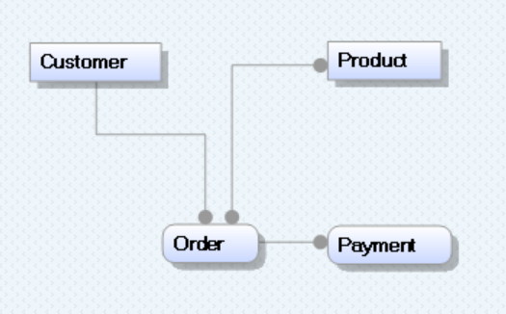
Figure 1: Conceptual Data Model

2.2 Logical Data Model
- Purpose: The logical data model provides a more detailed view of the data, focusing on the structure and relationships without considering how the data will be physically implemented.
- Components: It includes entities, attributes, primary keys, and foreign keys, as well as the relationships between entities.
- Audience: This model is used by data architects and analysts to ensure that the data structure is logically sound and meets the business requirements.
- Example: For the retail domain, the logical model would detail attributes for each entity, such as CustomerID, CustomerName, OrderID, OrderDate, ProductID, ProductName, PaymentID, and PaymentAmount, along with the relationships between these entities, as shown below.

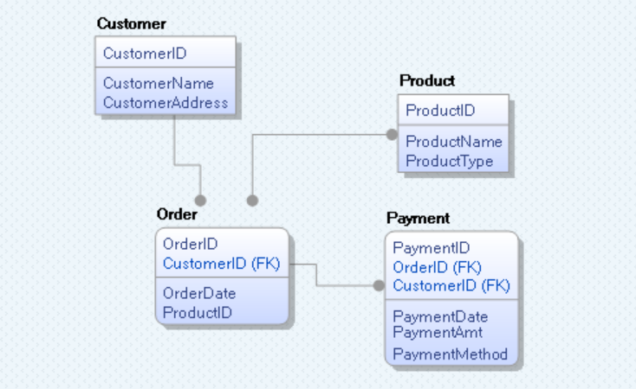
Figure 2: Logical Data Model

2.3 Physical Data Model
- Purpose: The physical data model translates the logical model into a technical blueprint for the actual implementation in a database. It focuses on how the data will be stored and accessed.
- Components: It includes tables, columns, data types, indexes, constraints, and relationships, as well as performance optimization considerations like indexing and partitioning.
- Audience: This model is used by database administrators and developers to create the database schema and optimize it for performance.
- Example: In the physical model for the retail business, the Customer entity might be implemented as a table with columns for CustomerID (integer), CustomerName (varchar), etc. Indexes might be created on frequently queried columns to improve performance. See a sample physical model below.

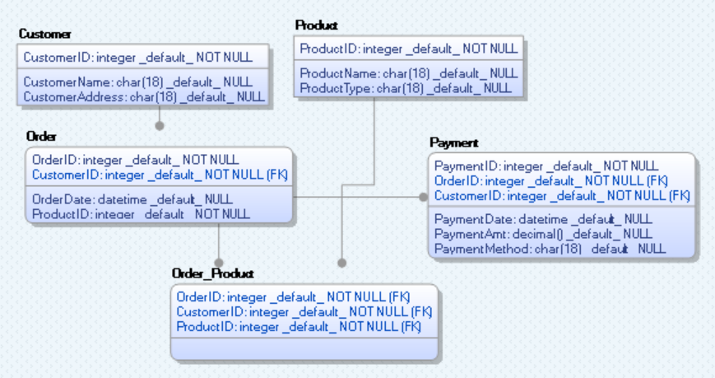
Figure 3: Physical Data Model

3. Roles & Responsibilities
The following key roles are recommended for managing and maintaining a data model within GDAI using a RACI framework:
Task | Data Steward | Data Architect/ Modeler | Delivery/ DevOps Team | Data Governance Lead | Data Owner | Data Maintainer
Define | R | C | C | C | A | C
Design | R | R | C | C | A | C
Build | C | R | R | I | I | R
Approve | R | C | I | C | A | I
Test | R | R | R | I | A | C
Deploy | C | C | R | C | I | R
Run | C | I | R | C | I | R
Maintain | R | I | R | I | A | R
R: Responsible, A: Accountable, C: Consulted, I: Informed

3.1 Data Steward
# Oversees governance, data quality, and business requirements
- Define: Responsible for developing business rules and metadata standards for governance.
- Design: Responsible for creating conceptual models reflecting governance and business needs.
- Build: Consulted on the development of physical models with maintainers.
- Approve: Responsible for reviewing and recommending data models for final approval by the owner.
- Test: Responsible for ensuring that models meet quality, security, and governance standards during testing.
- Deploy: Consulted on implementation of governance practices during deployment.
- Run: Consulted on ensuring adherence to governance practices in daily operations.
- Maintain: Responsible for updating governance policies and ensuring alignment with evolving data models.

3.2 Data Architect/Modeler
# Design conceptual, logical and physical models aligned with business requirements
- Define: Consulted on translating business rules into requirements for conceptual and logical models.
- Design: Responsible for developing conceptual, logical, and physical data models.
- Build: Responsible for creating physical models in collaboration with the delivery team and maintainers.
- Approve: Consulted on ensuring the accuracy and completeness of models before approval.
- Test: Responsible for validating the functionality and alignment of physical models with requirements.
- Deploy: Consulted on deployment by providing technical support related to models.
- Run: Informed about operational issues related to model implementation.
- Maintain: Informed about models changes due to business needs or governance.

3.3 Delivery/DevOps Team
# Builds and manages databases from implemented models
- Define: Consulted on database constraints and technical feasibility.
- Design: Consulted on the technical optimization of physical models.
- Build: Responsible for implementing physical data models into databases and configuring metadata.
- Approve: Informed about technical readiness for deployment.
- Test: Responsible for ensuring database functionality, performance, and security during testing.
- Deploy: Responsible for deploying the database infrastructure and finalizing access rules.
- Run: Responsible for monitoring database performance and resolving operational issues.
- Maintain: Responsible for updating database systems to reflect changes in data models and governance.

3.4 Data Governance Lead
# Leads enterprise policies and governance strategies
- Define: Consulted to ensure governance policies align with business strategy.
- Design: Consulted to ensure that governance policies are integrated into the design
- Build: Informed about the technical build to ensure alignment with governance standards.
- Approve: Consulted to confirm that data models comply with governance policies.
- Test: Informed about testing to monitor compliance with governance standards.
- Deploy: Consulted to ensure that deployment follows governance protocols.
- Run: Informed about the operational execution to ensure governance requirements are met.
- Maintain: Informed to ensure that governance practices are updated to align with organizational changes.

3.5 Data Owner
# Ensure data integrity, security, and regulatory compliance
- Define: Accountable for defining business rules, governance policies, and data asset ownership.
- Design: Accountable for ensuring the design of data models aligns with business goals, regulatory compliance, and governance standards.
- Build: Informed about the technical build of the data models to ensure compliance with governance policies.
- Approve: Accountable for the final approval of data models, ensuring they meet business, compliance, and governance requirements.
- Test: Accountable for ensuring data models pass tests for data quality, security, and compliance with governance standards.
- Deploy: Informed about the deployment process, ensuring it follows governance and compliance guidelines.
- Run: Informed about operational updates to ensure that data governance and regulatory requirements are met in daily operations.
- Maintain: Accountable for ensuring that governance policies are regularly updated to reflect changes in business needs or regulations.

3.6 Data Maintainer
# Handles technical operations and resolves data challenges
- Define: Consulted for technical input on the feasibility of business rules and governance policies.
- Design: Consulted to advise on technical design aspects of data models to ensure they are feasible and meet operational requirements.
- Build: Responsible for implementing the technical build of data models, including data pipelines, transformations, and data flows.
- Approve: Informed about the final approval of data models, ensuring alignment with the approved design and governance policies.
- Test: Consulted during the testing phase to address any technical issues and ensure the model is ready for deployment.
- Deploy: Responsible for deploying data models and ensuring they are technically sound and follow governance standards.
- Run: Responsible for monitoring and managing the technical operation of data models, addressing any issues related to data flow or performance.
- Maintain: Responsible for maintaining and updating the technical components of data models, ensuring they remain operational and efficient.

This structure helps ensure accountability, clarity, and collaboration in managing data models within the GDAI, leading to more efficient governance and data integrity.

4. Best Practices for Creating a Data Model
This chapter describes the basic principles and best practises when creating a data model.

4.1 Basic Principles
Initially there are a few basic principles to keep in mind when creating a data model:

- Don’t make people think
A model needs to be easy to understand from a business point of view
- Clarity over Completeness
The focus on this level lies on the description of major information objects and their relationships.
- Presentation Matters
It is important for the acceptance as well as the readability to keep the diagram clearly arranged and reasonably sized. Effort should be spent to name object and attribute as short and clear as possible.
- If in doubt, leave it out
If there are aspects which are hard to define, they should rather be left out altogether to avoid lengthy discussions over minor details.
- Once defined, stick to it
For name specifications this can be achieved with a Novo Nordisk business glossary.
- There can only be one (to rule them all!)
One Novo Nordisk model is defined. When communication with stakeholders' different views on the model help to focus on the task at hand.
- Seek feedback
Work with both business and technical teams from the start for better results.

4.2 Best Practices Overview

Best practice | Explanation | Relevance*
Purpose | Define clear objectives and business requirements | C
Ownership | State the ownership of the model | C
Business Approval | State the business approval status of the model | C
Entities | Identify important data items and their details | C, L, P
Definitions | Compose definitions for all model elements | C, L
Naming | Refer and use recommended naming conventions | L, P
Normalization | Organize data to avoid repeating information | L
Atomicity | Ensure each piece of information is simple and single | C, L
Integrity | Keep data accurate and consistent throughout | L, P
Data Redundancy | Check for and remove data redundancy | L, P
Performance | Make the system fast and efficient to use | P
Scalability | Design to allow for future growth easily | P
Validation | Review and refine the model regularly with feedback | L, P
Documentation | Refer and capture recommended details for easy reference | C, L, P
UML | Use UML as the visual model language | L
Coherence | Document the link between models at different abstraction levels | C
Reuse | Reuse existing models and model elements | L
Industry Standards | Refer to industry standards where possible | C, L
Syntactical Checks | Ensure no redundant dependencies or spelling mistakes | L, P
Sharing | Make data models available for everyone | P

*This column indicates which data modelling stage (Conceptual, Logical, or Physical) each best practice is most applicable to.

4.2.1 Purpose
# Define clear objectives and business requirements
Clearly define the goals of the data model or the specific use case it aims to illustrate.
Understand what business problem the model aims to solve, what data it needs to capture, and how it will be used by various stakeholders. This foundational understanding guides the entire modelling process and ensures alignment with business objectives.

4.2.2 Ownership
# State the ownership of the model
Ownership of and responsibility for the model and its elements must be clear and evident. Ownership in this context should be understood as the responsibility to vouch for the content and the structure of the model, and the commitment to keep it up to date. This information can also be relevant for other users to determine whether a model can be applicable for their purpose.

4.2.3 Business approval
# State the business approval status of the model
The model must be approved by a relevant forum. Depending on the type of data model this forum can be a selection of cross-business domain experts. This ensures that the model meets business requirements, has the support of those who will use it and can help secure necessary resources for implementation.

4.2.4 Entities
# Identify important data items and their details
Entities represent key objects or concepts relevant to the business. They are typically nouns and serve as the foundational components of the data model, such as Drugs, Patients, Prescriptions, Manufacturing Plants, Suppliers, Sales Orders, Clinical Trials, etc.
Each entity should be well-documented with its attributes (e.g., Drug ID, Patient ID) to provide clarity and facilitate effective data management and reporting.
Each entity must have a primary key or an identifier that uniquely identifies each record, and foreign keys that establish relationships between entities. Detailing the attributes of each entity is essential for clarity and effective data organization.

4.2.5 Definitions
# Compose definitions of all the model elements
To ensure that models and elements within models are understood in the same way across the GDAI and within the organisation, it is necessary to explain the meaning in a short and unambiguous description. This is the basis for a broad application and for minimising misinterpretations.

A definition should be written according to the following principles:
#1 – Definitions must be concise; they should be as short as possible and as complex as necessary. Potential additional information can be added in notes.
#2 – Definitions must be comprehensive; they should not be too narrow or too wide in their description of the term.
#3 – Definitions must be interchangeable with the term; they should therefore be written in one phrase starting with a small letter and not ending with a punctuation.
#4 – Definitions must not be circular; meaning they cannot refer to other terms.
#5 – Definitions must not be negative; they must describe what something is, and not what it is not.

Examples for definitions of a “wind power plant”:
Good: power plant that converts wind energy to electricity (intentional definition with the superordinate concept “power plant” and the properties that differentiates a wind turbine relative to other power plants)
Poor: Wind turbine (defined by a synonym – gives no further explanation)
Poor: e.g., wind turbines, wind farms in rural areas (defined by listing of subordinate concepts)
Poor: Power plants that do not convert chemical or electrical energy (defined by what it is not).

4.2.6 Naming
# Refer and use recommended naming conventions
Adopt consistent naming conventions and state meaningful names for models and model elements. This facilitates dissemination, search, and use of the model by a wider user group.
Naming conventions typically include rules for casing, singular vs. plural forms, and prefixes or suffixes that clarify the type of data represented. CamelCase and snake_case are common naming conventions that can be used.
Example: Use clear prefixes like DRG_ for drug-related data or PAT_ for patient data.

4.2.7 Normalization
# Organize data to avoid repeating information
Normalization is the process of organizing the data in a database to reduce redundancy and improve data integrity. This involves breaking down complex tables into simpler ones and defining relationships between them. The goal is to ensure that each piece of data is stored in only one place, which improves data integrity and reduces storage costs.
Example: In a normalized database, customer information would be separated into distinct tables (e.g., one for customer details and another for orders) to avoid repeating the same data.

4.2.8 Atomicity
# Ensure each piece of information is simple and single
Ensure that each attribute in the data model is atomic, meaning it stores a single, indivisible value. This principle prevents ambiguity and complexity.
Example: Rather than having a field for "full name," separate it into "first name" and "last name." Similarly, break “full address” into “street”, “city”, “state”, and “postal code” for enhanced clarity and easier data manipulation.

4.2.9 Integrity
# Keep data accurate and consistent throughout
Maintain data accuracy and consistency throughout the model by defining primary keys (unique identifiers for records) and foreign keys (links between tables) to enforce relationships and constraints.
Define directionality in relationships between entities (e.g., one-to-many or many-to-one) to accurately model real-world connections and maintain referential integrity across tables.
Specify attribute-level nullability requirements to ensure that essential fields are not left blank, which supports model integrity by avoiding incomplete records.
Implementing integrity checks helps ensure that invalid data cannot enter the system.
Example: A “Prescription” entity must have a valid, non-null “Patient ID” linked to the “Patient” entity. This enforces a one-to-many relationship, where each prescription belongs to only one patient, ensuring accurate patient-prescription relationships.

4.2.10 Data Redundancy
# Check for and remove data redundancy
Data Redundancy specifically addresses the presence of duplicate data in the database after normalization has been applied.
Normalization is more about structuring the data correctly, whereas data redundancy focuses on ensuring that there are no duplicates left in the model. The goal is to ensure that each piece of information is stored only once, which minimizes the chances of errors and inconsistencies.
Example: After normalizing the database, if a customer's address is still stored in both the customer and order tables (and it's the same), that would be an example of data redundancy that needs to be addressed.
In a normalized database, customer information would be separated into distinct tables, one for customer details and another for orders, to avoid repeating the same data.

4.2.11 Performance
# Make the system fast and efficient to use
Design the model with performance in mind. This includes optimizing query efficiency through indexing, minimizing complex joins, and considering the balance between normalization and denormalization based on usage patterns. A well-performing model ensures faster data retrieval and a better user experience.

Here are some key points to keep in mind:

#1 – Choose Key Fields Wisely: Ensure that fields like primary keys (e.g., Prescription ID, Drug ID) are unique and well-structured to support fast lookups and data retrieval.
#2 – Minimize Redundancy: Design the model to avoid duplicate data across tables, which helps reduce storage space and keeps the system running efficiently.
#3 – Index Important Fields: Plan for indexing key fields that are frequently searched (e.g., Patient Name, Drug Name), allowing the database to retrieve information quickly.
#4 – Use Appropriate Data Types: Assign the correct data types (e.g., numbers, text, dates) to fields to ensure efficient storage and fast access.
#5 – Optimize Relationships: Establish clear and efficient relationships between entities (e.g., Patient and Prescription) to minimize unnecessary joins or data lookups.
#6 – Balance Normalization and Denormalization: Normalize the data to eliminate redundancy but consider denormalizing certain parts of the model to improve read performance when necessary.

4.2.12 Scalability
# Design to allow for future growth easily
Create a data model that can grow and adapt as business needs change. Consider the following principles:

Design for Flexibility:
#1 – Use generic attributes like Location or Region instead of hardcoding specific values.
#2 – Make use of optional fields or tables to accommodate future needs without redesigning the entire model.

Modular Approach:
#1 – Create separate entities for core elements (e.g., Country, Product, Regulations), allowing each to be updated independently.
#2 – Use relationships to link these entities, so you can add new elements (e.g., new countries or regulations) easily.

Anticipate Growth:
#1 – Design with scalable relationships, such as one-to-many or many-to-many, where needed (e.g., one product sold in multiple countries).
#2 – Avoid overly complex joins between tables to prevent future performance issues as data grows.
Support New Use Cases:
#1 – Use abstracted or generalized entities that can handle various business cases (e.g., Sales Channel entity for both retail and online).
#2 – Ensure your model supports future business flows by keeping it loose but logical, so new scenarios don’t break existing structures.

4.2.13 Validation
# Review and refine the model regularly with feedback
Regularly review and refine the model based on feedback from stakeholders and users. Validation includes testing the model against real-world scenarios, ensuring it accurately represents business processes and data requirements. Continuous improvement keeps the model relevant and effective.
Example: Specify any validation checks or constraints placed on data (e.g., prescription date cannot be in the future).

4.2.14 Documentation
# Refer and capture recommended details for easy reference
Capture detailed documentation for clarity and governance. Here’s a list of what should be captured in the documentation for a data model:

1. Entity Definitions: Descriptions of all entities (e.g., Patients, Drugs, Clinical Trials) and their roles.
2. Attribute Details: Definitions and types of all attributes (e.g., Drug ID, Patient Name), including primary and foreign keys.
3. Relationships: Document how entities are related, including one-to-one, one-to-many, and many-to-many relationships.
4. Metadata: Capture data about the data, like creation date, data owner, and data sensitivity levels.
5. Business Rules: Any business logic or rules governing data (e.g., valid drug expiration periods).
6. Assumptions: Document assumptions made during the design (e.g., specific country regulations may vary).
7. Version Control: The version and time of latest update for a model must be stated, so that a user can assess whether a given model or elements of it can be used for a particular purpose.
8. Decisions: Record decisions made during the modelling process, along with justifications.
9. Data Flow Diagrams: Visuals showing how data moves through systems.
10. Glossary: A glossary of key terms used in the data model for easy reference.
11. Technical Specifications: Any relevant technical details, such as indexing strategies or partitioning for performance optimization.

Good documentation aids in knowledge transfer, governance, maintenance, and onboarding new team members.

4.2.15 UML
# Use UML as the visual model language
Models are preferred to be defined as UML class diagrams. The rationale behind this is that UML class and object diagrams are a standardised, accessible, and sufficiently unambiguous way of visualising models.
The visually simple expression in a UML diagram can serve as an easy-to-understand representation of the business concepts and as a means of communication between data modellers and programmers, but also between people from different business areas throughout the development process from idea to implementation of solutions.
If another modelling language is preferred, it is highly recommendable that it can easily be converted to a UML, so that the model can be stored in the same visual language as the rest of the models and can be stored and displayed the same place.
Novo Nordisk has approved the use of Erwin a modelling tool from Quest, and this is the tool being used within GDAI.

4.2.16 Coherence
# Document the link between models at different abstraction level
Any new developed model must identify which conceptual model(s) is it based upon. By ensuring coherence between the conceptual, logical, and physical models that exist, organisational and semantic interoperability is provided, and the connection from business to data is ensured.

4.2.17 Reuse
# Reuse existing models and models elements
Creation of new models or model classes should only be done if a corresponding one doesn’t already exist. Several commonly used models have been developed with the purpose of re-use across areas.
Example: Contact Information (address, mail, telephone), Consent, and Qualifications.
As the data modelling work progresses within GDAI and across the organisation the list of “on-the-shelf” data models to reuse will also grow.

4.2.18 Industry standards
# Refer to industry standards where possible
Industry standards should be used to the extent possible, to further enhance standardisation and sharing of data. When applying industry standards, the modelling exercise will also be easier, than when having to create a new model from scratch.

Here are some industry standards to follow while creating a data model:

#1 – Follow Standard Data Types: Use standard data types (e.g., VARCHAR, INTEGER) to ensure compatibility across systems.
#2 – Ensure Compliance with Regulations: Incorporate data privacy and compliance requirements (e.g., GDPR, HIPAA) directly into the model.
#3 – Use Metadata Standards: Include metadata to describe data attributes, following standards like Dublin Core or ISO/IEC 11179.
#4 – Leverage Referential Integrity: Ensure the model enforces referential integrity through foreign key relationships.

These standards improve the model’s usability, interoperability, and compliance.

4.2.19 Syntactical checks
# No spelling mistakes

4.2.20 Sharing
# Data models should be available for everyone
The data models created both within GDAI, but also across other parts of the business should be made available for everyone, to increase standardisation and reuse.

5. References

DAMA International. DAMA-DMBOK: Data Management Body of Knowledge (2nd ed.). Basking Ridge, NJ: Technics Publications, 2017. This reference offers foundational concepts in data management, including data modelling, governance, and documentation standards.

Garcia-Molina, H., Ullman, J.D., & Widom, J. Database Systems: The Complete Book. Upper Saddle River, NJ: Prentice Hall, 2008. A technical reference that covers database theory and applications, including data modelling best practices such as normalization, atomicity, and syntactical checks.

Kimball, R., & Ross, M. The Data Warehouse Toolkit: The Definitive Guide to Dimensional Modelling (3rd ed.). Indianapolis, IN: Wiley, 2013. This book emphasizes entity definition and data redundancy reduction within data warehousing, aligning with best practices in data modelling.

Simsion, G.C., & Witt, G.C. Data Modelling Essentials (3rd ed.). San Francisco, CA: Morgan Kaufmann, 2005. A comprehensive guide to data modelling practices, including definitions, naming conventions, and UML for data models.

Briney, K. Data Management for Researchers: Organize, Maintain and Share Your Data for Research Success. Exeter, UK: Pelagic Publishing, 2015. This book offers insights into data validation and documentation, relevant to maintaining data accuracy and transparency in models.

Gartner. “Data Modelling.” Gartner Information Technology Glossary. https://www.gartner.com/en/information-technology/glossary/data-modelling. This source provides an industry overview of data modelling practices, highlighting the role of governance, integrity, and quality in data model development.

Gartner. “Technology Adoption Roadmap for Data and Analytics Functions for 2024.” Gartner Research. 2023. This roadmap discusses emerging trends in data governance, data quality, and best practices in data modelling, including scalability and validation.

Boston Consulting Group (BCG). “Data Capability Maturity Assessment.” BCG Digital Transformation Insights. https://www.bcg.com. This publication offers a diagnostic approach to data capabilities and governance, supporting best practices in model scalability, coherence, and purpose alignment.

Deloitte. “Building a Data-Driven Organization: Key Strategies and Frameworks.” Deloitte Insights. https://www.deloitte.com. Deloitte emphasizes aligning data models with business strategy and ensuring model coherence and ownership.

Accenture. “Applied Intelligence: Data-Driven Transformation.” Accenture Digital Transformation Publications. https://www.accenture.com. This source focuses on data strategy frameworks and best practices for model reuse, performance, and scalability within an enterprise context.

Ladley, J. Data Governance: How to Design, Deploy, and Sustain an Effective Data Governance Program (2nd ed.). Waltham, MA: Morgan Kaufmann, 2020. Ladley’s work discusses business approval and ownership as part of effective data governance, which supports best practices in data modelling for regulatory and operational compliance.

McKinsey & Company. “A Blueprint for Data Transformation: Turning Data into a Strategic Asset.” McKinsey Digital Insights, 2023. https://www.mckinsey.com. This whitepaper outlines strategic approaches to data modelling, focusing on coherence and alignment with business goals.

The roles outlined in this RACI may not always exist in every LoB, but they represent key responsibilities that must be assigned to ensure effective data governance and management.

